Multiple-choice section – choose the correct answer

Question 1 [3.1]

The coefficient of *x* in -4*x*2 + 3*x* + 5*xy* – 7 is:

A -4 B 3 C 5 D -7

Question 2 [3.2]

If *q* = , what is the value of *q* where *p* = -4?

A -2.5 B -13.5 C 3.5 D 13.5

Question 3 [3.2]

If *a* = -2 and *b* = 3, then 7*a*2 – 4*b*3 is:

A -136 B 136 C -80 D 80

Question 4 [3.3]

The formula *s = ut +* is used to find the speed of an object. If *u =* -30, *a* = 15 and *t* = 5 are substituted into the formula, *s* is equal to:

A 37.5 B 337.5 C -112.5 D -337.5

Question 5 [3.4]

Subtract 4*x* – 3*y* + *z* from 2*x* + 7*y* – 2*z*.

A 2*x* – 4*y* – *z* B -2*x* + 10*y* – 3*z* C -2*x* + 4*y* + *z* D -2*x* – 10*y* + *z*

Question 6 [3.5]

Simplify -2*a* × 8*b* × -4*c*.

A -64*abc* B 2*abc* C 12*abc* D 64*abc*

Question 7 [3.5]

Simplify 25*e* ÷ -40*ef* × 8*f*.

A -5 B -5*f* 2 C -  D -

Question 8 [3.6]

Expand the expression -5*mn*(*m*2 – 9*n*).

A -5*m*3 – 13*n*2 B -5*m*3 + 13*n*2 C -5*m*3*n* – 45*mn*2 D -5*m*3*n* + 45*mn*2

Question 9 [3.6]

When the expression 2*g*(3*g* + 4) – 3(*g*2 + 8) is expanded and simplified, it is equal to:

A 3*g*2 – 24 B 3*g*2 + 8*g* – 24 C 3*g*2 + 8*g* + 24 D 9*g*2 + 8*g* + 24

Question 10 [3.7]

Factorise 4*ab*2 – 16*abc*.

A 4(*ab*2 – 4*abc*) B 4*a*(*b*2 – 4*c*) C 4*ab*(*b* – 4*c*) D -4*ab*(*b* + 4*c*)

Multiple-choice results: ___ / 10

Short answer section

Question 11 3 marks

Choose the correct word from the following list to fill the gaps in the following sentences.

*like terms coefficient factorising expanding constant formulas*

(a) Writing an expression with a common factor and brackets is called ____________________  
an expression.

(b) Using the distributive law to write an expression without brackets is called __________________ an expression.

(c) When *a* – 2*b* + 5*a* + 6*b* is simplified to 6*a* + 4*b*, you have collected ____________________.

Question 12 3 marks [3.2]

Tammy answered the question below in a maths test, but she made a mistake.  
Circle the error and write the correct solution.

Substitute *a* = -3 and *b* = 5 into the following expression: 6*ab* – 2*b.*

Tammy’s working

6*ab* – 2*b*

= 6 × -3 × 5 – 2 × 5

= 90 – 10

= 80

Question 13 5 marks [3.2]

Given that *p* = 2, *q =* -5 and *r* = 3, evaluate:

(a) 2*pq* (b) *q*(*p* + *r*)

(c) (2*p* – *q*)(*q* – 2*r*)

Question 14 3 marks [3.3]

The kinetic energy, *E*, of an object can be calculated from the formula *E* = *mv*2, where *m* is the mass of the object and *v* is its speed.

(a) Find the kinetic energy of an object that has a mass of 55 kg and is moving at a speed of 12 m/s.

(b) An object moving at 10 m/s has a kinetic energy of 3750 J. What is its mass?

Question 15 3 marks [3.4]

Simplify these expressions, where possible.

(a) 11*r* – 7*r* – 9 (b) 24*d* – 8*h* + 2*d* + 12*h* (c) 12*x* + 2 – (13 – 9*x*)

Question 16 5 marks [3.5]

Simplify each of these expressions.

(a) -6*a* × 2*b* × 7*a* (b) × 28*hk*

(c) 36*x*2*y*2 ÷ 4*xy* + (-11*y*) × 3*x*

Question 17 5 marks [3.6]

Expand and simplify each of the following expressions.

(a) -3(7*r* – 5) (b) 8*x*(*y* – 4) – 6*xy*

(c) 5*m*2(2*n* – 5) – 12*m*(3*m* + *n*)

Question 18 3 marks [3.4, 3.5]

(a) Write an expression for the perimeter of the shape below, and simplify it.

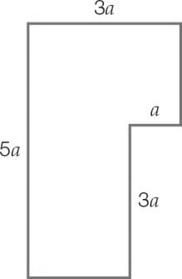

(b) Write an expression for the area of the shape above, and simplify it.

Question 19 5 marks [3.7]

Factorise the following expressions.

(a) 3*xy* – 21*y*2 (b) 52*b*3*c*– 24*bc* (c) 10*cd*2 + 18*c*2*d –* 48*c*3*d*2

Short answer results: ___ / 35

Extended answer section

Question 20 9 marks [3.2, 3.4, 3.6, 3.7]

(a) Flocks of birds often fly in V patterns, as shown in these diagrams.

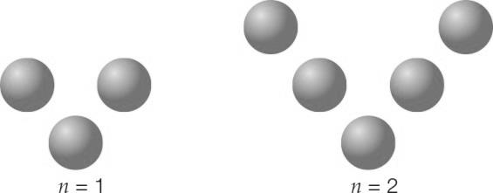

The number of pairs of birds behind the leading bird (the single bird at the vertex of the V) is represented by the letter *n*. The total number of birds in the V pattern is represented by the letter *B*. The formula relating *n* and *B* is *B* = 2*n* + 1.

(i) In the table, complete the column labelled *B*.

|  |  |  |
| --- | --- | --- |
| *n* | *B* | *J* |
| 1 | 3 | 5 |
| 3 | 7 |  |
| 6 |  | 25 |
| 7 |  |  |

(ii) If 127 birds are seen flying in a large V pattern, what is the value of *n*?

(b) Groups of fighter jets often fly in W patterns, represented by the formula *J* = 4*n* + 1,  
where *n* = number of pairs behind each leading jet and *J* = total number of jets.   
Complete the column labelled *J* in the table above.

(c) One day, some flocks of birds flying in V patterns are seen together with some jets flying in W patterns.

(i) Write an expression for the total number of birds and jets.

(ii) Factorise the expression in (c)(i).

(d) The expression (*a* + *b*)(*c* + *d*) can be expanded by rearranging it to *a*(*c* + *d*) + *b*(*c* + *d*). Use the same method to obtain an expression for *B* × *J*.

Question 21 3 marks [3.1]

Nina is one third the age of her brother, Michael. In eight years’ time, she will be half her brother’s age. If Nina is *n* years old:

(a) write an expression in terms of *n* to show how old Michael is now

(b) write two different expressions in terms of *n* to show how old Michael will be in eight years’ time.

Question 22 10 marks [3.1, 3.4, 3.6]

A rectangle has dimensions such that the length is 10 cm longer than the width. This is represented by the diagram below.

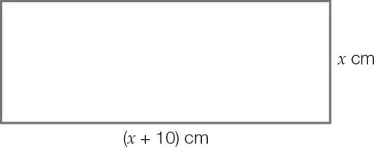

(a) Write an expression for the area of the rectangle. Expand and simplify your expression.

(b) The length is increased by 75% and the width is increased by 50%.

(i) Write an expression for the new length and width of the rectangle.

(ii) What is the area of this new rectangle? Expand and simplify your expression.

(iii) What is the increase in the area of the new rectangle? Comment on this increase.

(c) After these increases, the perimeter of the new rectangle is 100 cm.

(i) Suggest a value for *x*.

(ii) Use this value to calculate the perimeter of the original rectangle.

Extended answer results: ___ / 22

TOTAL test results: ___ / 67